What is data?
Data is a collection of raw, unorganized facts, figures, observations, or symbols.
Text → "Hello"
Images → photos, diagrams
Audio/Video → songs, recordings
Measurements → temperature, height, speed
Simple Definition
Data is raw information used to gain knowledge or make decisions.
Types of Data
- Qualitative Data – descriptive information
Example: color, name, gender
- Quantitative Data – numerical information
Example: age, marks, salary
Real-Life Example
A school collects:
- Student names
- Marks
- Attendance
These collected facts are called data.

What is database?
A database is an organized collection of related data that is stored electronically and can be easily accessed, managed, and updated.
Simple Definition
A database is a place where information is stored in a structured way.
Types of Databases
- Relational Database
Data is stored in tables (rows and columns).
Example: MySQL, Oracle Database
- NoSQL Database
Used for large-scale or unstructured data.
Example: MongoDB
Why Databases Are Used
Databases help to:
- Store large amounts of data
- Retrieve information quickly
- Update data easily
- Reduce duplication
- Improve security and accuracy
Example
A college database may store:
- Student ID
- Name
- Department
- Marks
- Attendance
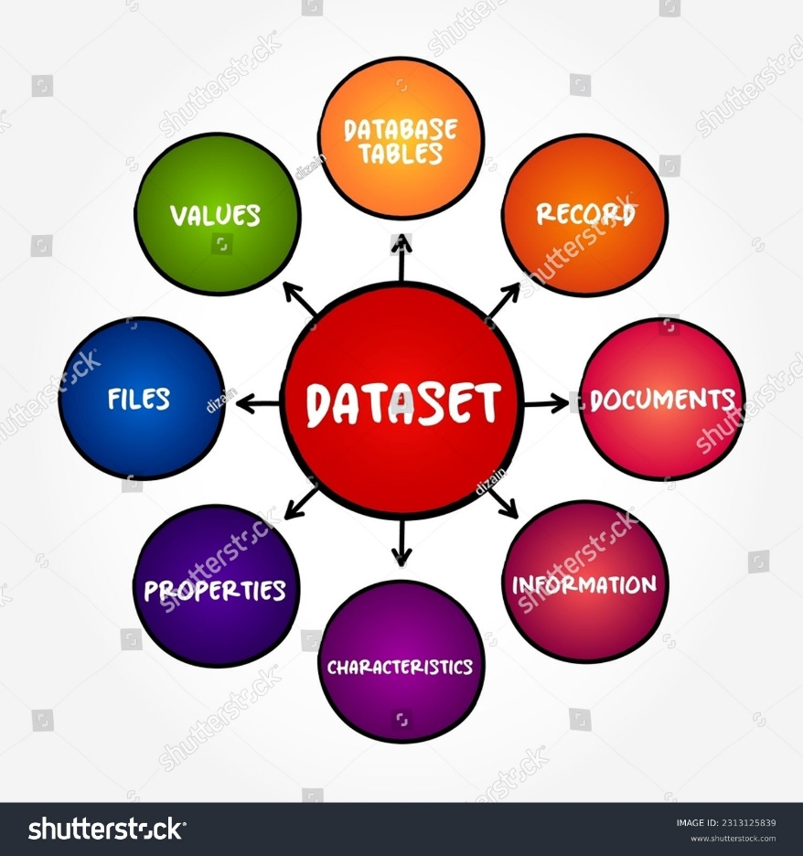

Why do organizations store data in databases?
Organizations store data in databases because databases help manage information efficiently, securely, and accurately.
Main Reasons
- Easy Storage of Large Data
Databases can store huge amounts of information in an organized manner.
- Fast Access and Retrieval
Users can quickly search and retrieve required information.
- Data Security
Databases provide passwords, permissions, and backup features to protect data.
- Reduced Data Redundancy
Duplicate data can be minimized, saving storage space and improving consistency.
- Easy Updating and Maintenance
Information can be added, modified, or deleted easily.
- Data Sharing
Multiple users can access the same database simultaneously.
- Improved Accuracy and Consistency
Databases help maintain correct and uniform information.
- Backup and Recovery
Data can be recovered if systems fail or data is lost.

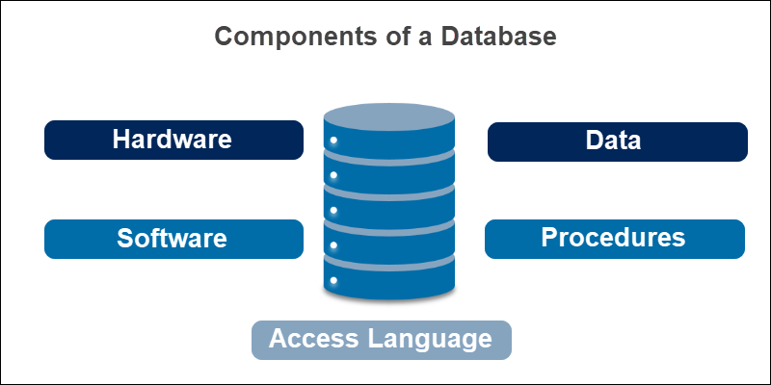
Example
A bank stores customer details, account balances, and transaction records in a database so employees can quickly access and update information securely.

Give examples of relational database?
Examples of relational databases include:
- MySQL
  - Open-source and widely used for web applications.
- Oracle Database
  - Commonly used in large enterprises and banking systems.
- Microsoft SQL Server
  - Developed by Microsoft for business applications.
- PostgreSQL
  - Known for reliability and advanced features.
- SQLite
Used in mobile apps and embedded systems.
- IBM Db2
Developed by IBM for enterprise data management.
Common Feature
All relational databases store data in the form of tables consisting of rows and columns.

What is data warehouse?
A data warehouse is a centralized system used to store large amounts of historical data collected from different sources for analysis and decision-making.
Simple Definition
A data warehouse is a storage system that combines data from multiple databases and systems into one place for reporting and analysis.
Features of a Data Warehouse
- Stores historical data
- Integrates data from different sources
- Supports business analysis and reporting
- Helps in decision-making
- Optimized for querying and analytics

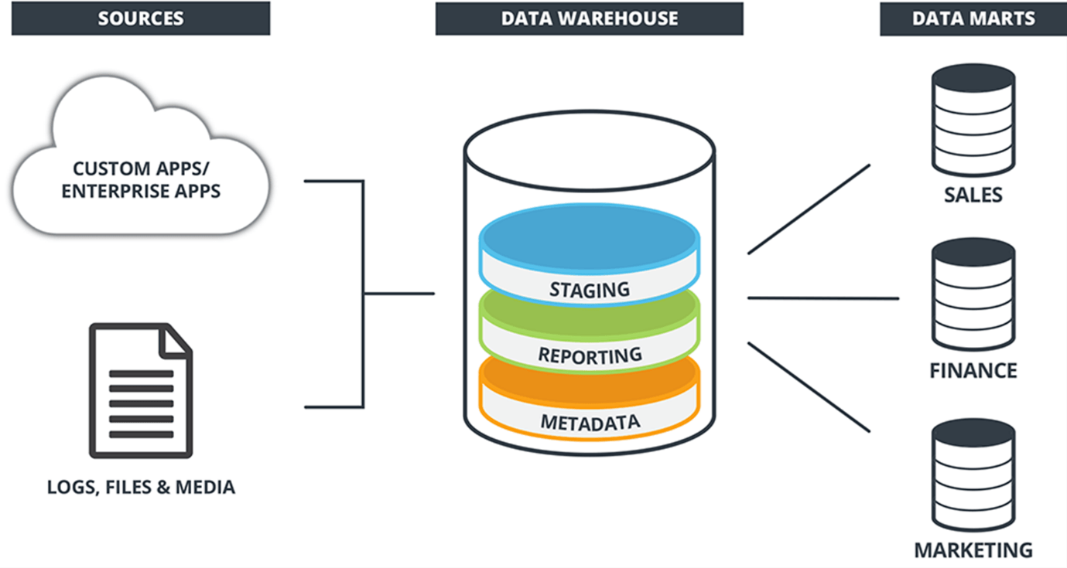

Example
A supermarket company may collect data from:
- Sales systems
- Customer records
- Inventory systems
- Online orders
All this information is stored in a data warehouse to analyze:
- Best-selling products
- Customer buying patterns
- Monthly profit trend

Examples of Data Warehouse Tools
- Amazon Redshift
- Google Big Query
- Snowflake
- Teradata

